Chris Hui

ASL

**Rudder Box Report**

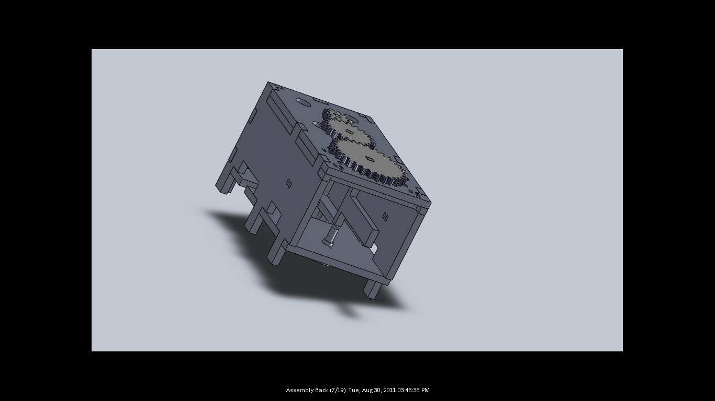

*Fig. 1: Rear View of Finished Rudder Box Assembly in SolidWorks*

/ / This paper, written from 8/23/2011 to 9/1/2011 (10 days), is an attempt to document as much of the design and construction process that went into building the rudder box which we worked on from 7/18/2011 to 8/22/2011 (36 Days). It is intended to be able to convey exactly what we did, why we did it, and how we did it to someone somewhat familiar with basic CAD, laser cutting, and/or manual assembly. / /

Table of Contents

I. About . . . . . . . . . . . . . . . . . . . . . . . . . . . . . . . . . . . . . . . . . . . . . . . . . . . . . . . . . . . . . pg. 1 - 2

II. Making . . . . . . . . . . . . . . . . . . . . . . . . . . . . . . . . . . . . . . . . . . . . . . . . . . . . . . . . . . . . pg. 3 -

III. Our Thoughts . . . . . . . . . . . . . . . . . . . . . . . . . . . . . . . . . . . . . . . . . . . . . . . . . . . . . . . pg. 6 -

**---------------------------------------------------------------------------------------------------------------------**

[1] About

*a) What did we do?*:

We built a model rudder box that replicates the rudder box of a boat of ours on a smaller, portable scale. Basically, what we did was build a 4 inch by 8 inch box with an open back that's designed to fit a gear train on its top, and a small motor and rudder inside. We then finished our setup by putting 2 LEDs, 2 magnet sensors called Hall Effect Sensors, and a magnet in the mix. The result? A portable rudder box capable of serving as a robust rudder angle test platform.

*b) Problem*:

Before we had built this rudder box, we had to constantly go back and forth between our lab and an outside parking lot, where we have our physical boat located, if we wanted to conduct any live tests involving an actual rudder on the control algorithm we've been designing for our boat's autonomous rudder system. Typically, such a trip would involve wasting a lot of time and energy moving a lot of equipment in an out, as during testing we might discover hardware or software bugs that can only be fixed with equipment we might have left back in lab. One small incident like that could stop testing for a good 20 minutes. And for a long term project like ours that is projected to span several years, that's not a good thing. If we could do all our live rudder testing in lab somehow, that would save us a great deal of trouble.

*c) Our Answer*:

Since all we were doing when we went outside to conduct live tests on the boat's rudder control algorithm was hook up a computer to the boat's rudder system and send data that should (if everything is working right) move the rudder either right or left by "X" degrees (where X is a variable controlled by the data we send) and create a resulting rudder angle which we expected; we figured we could just make a scaled-down replica of our boat's rudder system and just run our computer programs on that. What we ended up building was a small rudder box capable of testing the control algorithm responsible for autonomously controlling our boat's rudder angle.

*d) Why that way?*:

We decided to do things this way for two reasons outside the fact that we knew it could get the job done. First of all doing it this way made the final product really easy to envision, as all we would be doing would be a scaled down replication. Replication would only require that we have knowledge of what parts are going to be involved in building the rudder box, and how we might reproduce those parts. With all of the parts involved (a box, motor, gear train, rudder, potentiometer) being relatively easy to understand, and either available lying around our lab or possible to construct using a laser cutter (which we have), it's a very straightforward job.

The other reason why we decided to do things this way, is that it would provide a gentle introduction for someone new to our lab to learn how to 3D model, laser cut, and work with basic electronics by getting a chance to use all those skills in actual product design.

[2] Making

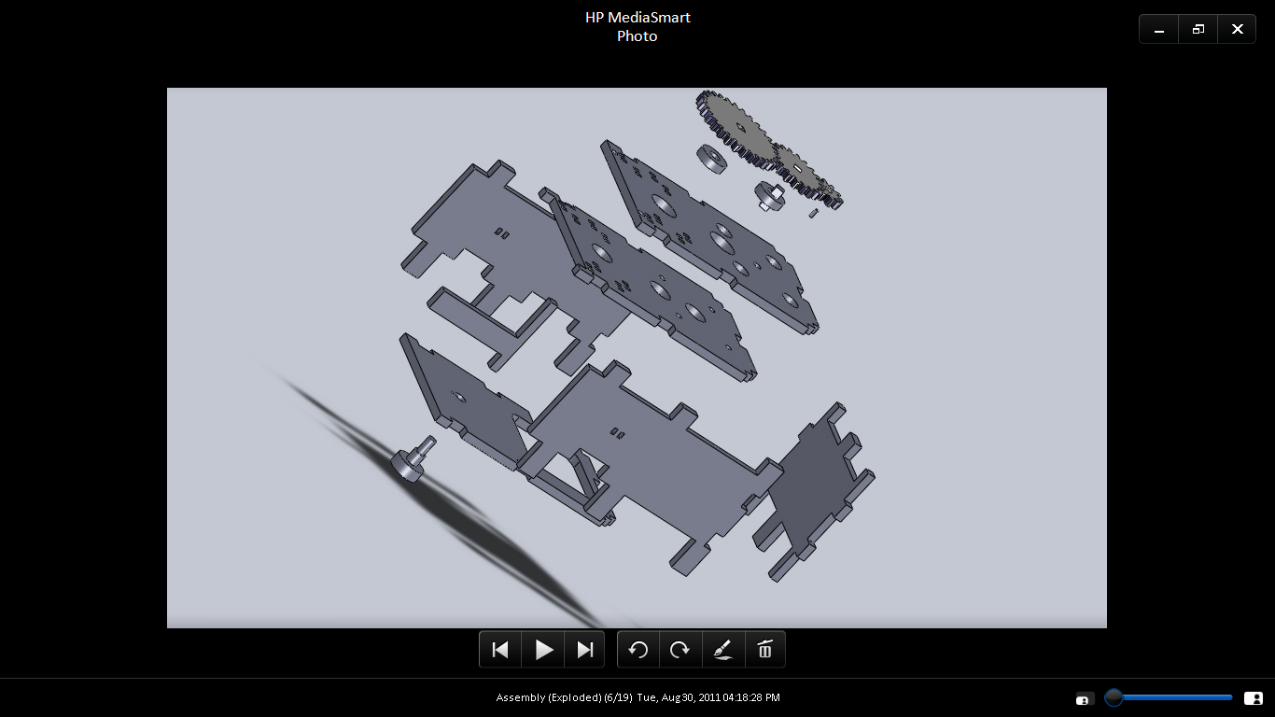

*Fig. 2: Exploded Side View of Rudder Box Assembly in SolidWorks*

*a) Overview:*

The gearbox was realized through a four-step process involving CAD, Laser Cutting, Assembly & Testing, and Redesign (which starts the whole process over again in what we a "reiteration"). Our design went through a lot of such reiterations before we were finally happy with what we got. Directly below this section is a barebones cookbook approach to building our rudder box. What it doesn't talk about is the history of how we got there. That we'll save for later, when we starting talking about the specific redesigns we made on this product towards the end of this section.

Process:

I. CAD

1. Draft Design on Paper

2. Measurements Using Calipers

3. Model Pieces in SolidWorks

II. Laser Cutting

1. Laser Cut Pieces

**1/4" Foamcore Pieces (Optional - Testing)**

1.-11. All

1/4" MDF Pieces

1. Top 1

2. Top 2

3. Side w/ Port

4. Side

5. Front

6. Bottom

7. Rudder

8. Rod

1/4" Acrylic Pieces

1. 10 Gear

2. 20 Gear

3. 30 Gear

III. Assembly

1. Wood Glue Box

2. Screw In Motor

3. Put in Washers

4. Fix Gear Train

5. Place LEDs

6. Wire LEDs

7. Tape Hall-Effect Sensors

8. Zip Tie Hall-Effect Sensors

**5-8. Test LED/Hall Effect Sensors Using Breadboard (Optional - Testing)**

9. Fix Potentiometer

10. Heat Shrink Rudder

11. Tape Magnet to Rudder

**11. Test Magnet/LED/Hall Effect Sensor Setup (Required -Testing)**

12. Hot Glue Gears

*b) Part 1: CAD Design*

Using:

**-** Pencil and Paper

**-** Calipers

- SolidWorks 2010

The main program we used for our CAD drawings was SolidWorks 2010. We used it to determine the dimensions of all the extruded pieces we need to have cut out as well as some pieces we don't need to have cut but would like to model anyway just to see how things fit. But before we drew anything in SolidWorks, we drew it on paper using pencil.

First drawing a rough sketch of what we wanted, we then took measurements of the parts we knew we would be using straight from the shelf, around which we would be building the rest of our assembly. These pieces being the motor, potentiometer, LEDs, washers, Hall Effects, wire, screws, and magnet.

This means taking into consideration the sizes of these pieces when designing the box which is supposed to contain them. If this step was done well in the beginning we could have very well cut our production time down by approximately 60% (as that was roughly how much time was spent reworking parts measurements in CAD). Knowing exactly what you want saves a lot of time. We should have only begun modeling parts in SolidWorks only after having a clear layout of what we're trying to model in front of us.

After getting all their measurements correct, drawing the 11 Pieces in SolidWorks one at a time is a piece of cake. All it is really , is designing the 6 pieces of the box, 3 gears using Gear Template, and a rod and rudder that all fit together where they are supposed to. If the measurements were done correctly everything would just fall into place. The pain of SolidWorks comes from trying to make fixes in the program, as often if one thing is off it usually takes fixing more than just that one thing to get what you want.

The SolidWorks skills required for this particular project are actually quite basic: all you need to know is how to make shapes, extrude them, make extruded cuts, smart dimension, mate in assembly, and if you want to get fancy use fillet and/or explode like we ended up doing. All this can be easily learned via the SolidWorks tutorials. Again, the hard part is working with measurements. Everything has to fit perfectly.

The way to check if everything fits, is to take all the individual parts and combine them in a SolidWorks Assembly. After mating everything together, If they fit the way they are supposed to everything's good to go. Checking to make sure carefully that they actually fit in SolidWorks can also save a lot of time. It's imperative you check that there are no overlaps (as SolidWorks will let this happen without alerting you) or gaps.

If we had done it correctly the first time it could have very well saved us 20% of the time we spent. Laser cutting takes time, and laser cutting a faulty assembly and then trying to assemble it only to find it halfway through assembly that something isn't right forces us to stop what we're doing and make premature reiterations that might better be saved for later when we've got more changes to make.

With the assembly looking then good, we try to brainstorm any improvements that we could possibly make to it. Thinking up these possible upgrades before doing any laser cutting also saves a lot of time and can cut down the number of reiterations you have to make significantly.

On this project, We had a tendency to only think up of only one upgrade per trip to the laser cutter and that made us take around 6 or 7 reiterations when really we should have only needed half as many in order to get the same results. Just committing to think of two upgrades per reiteration instead of just one would have saved us a considerable amount of time and raw material.

When we're finally ready to cut, what we do next is put all our individual parts into a SolidWorks drawing file as 2D shapes and then position all the shapesclose together without overlap as close to the edge of the top right corner as possible before saving it as a .DXF file.

Below are the 11 parts we designed in SolidWorks (and their specs) that need to be cut for the rudder box. Unlabeled sides have a corresponding labeled side with the measurements either in the drawing of the same piece or a similar piece.

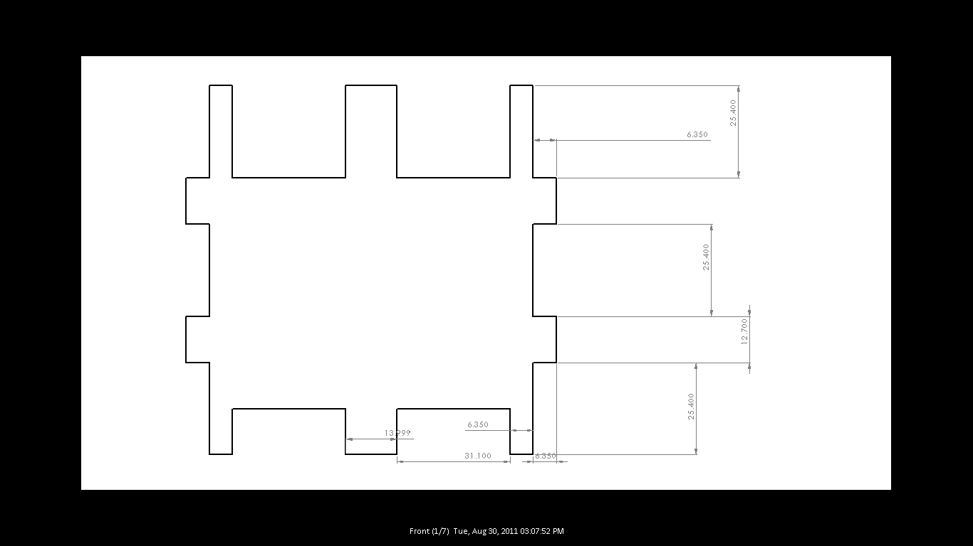

Fig. 3: *Front*

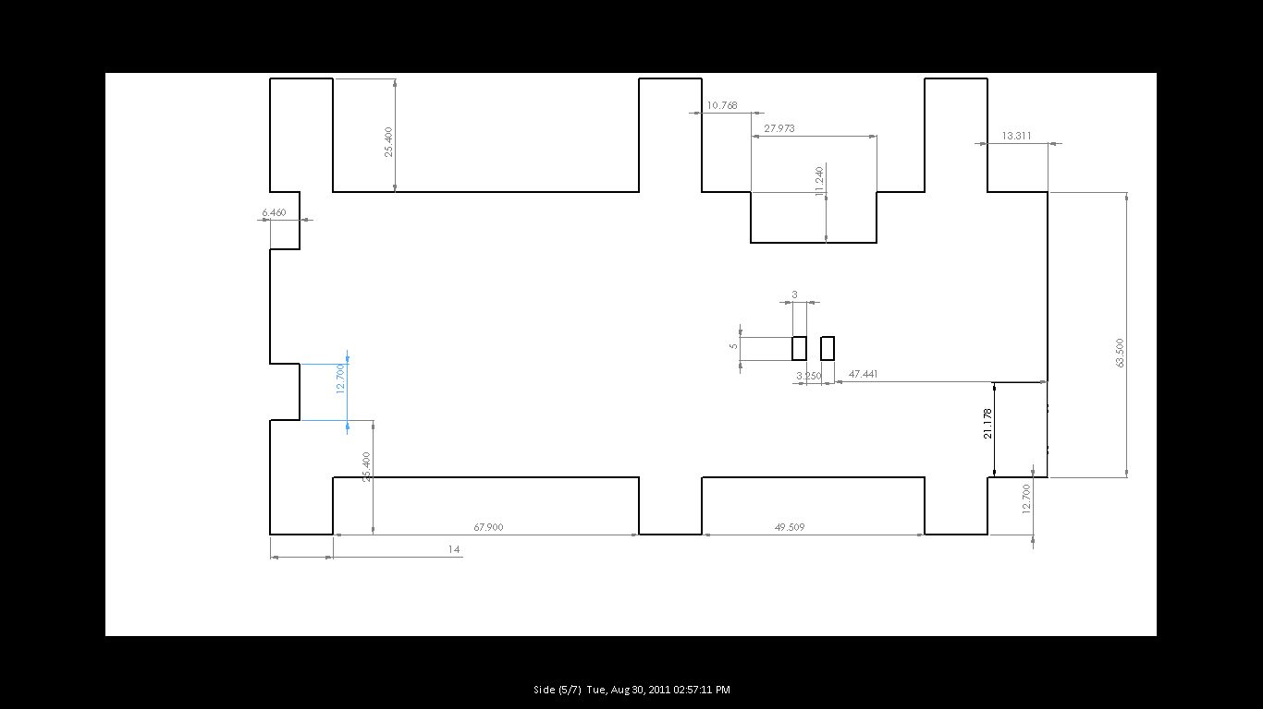

Fig. 4: *Side*

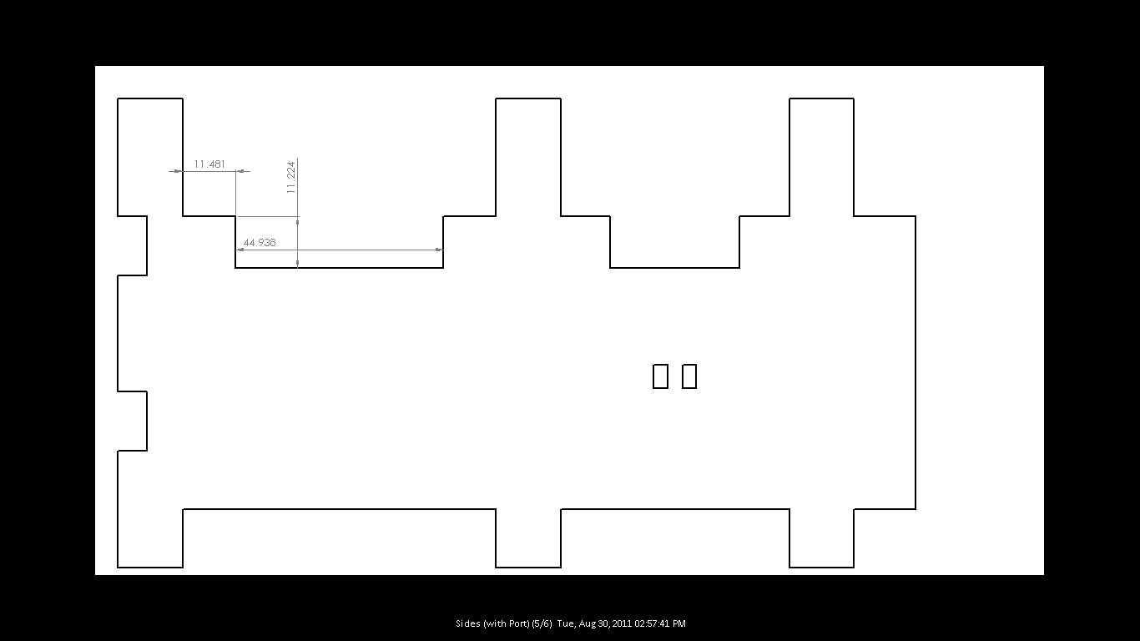

Fig. 5: *Side With Port*

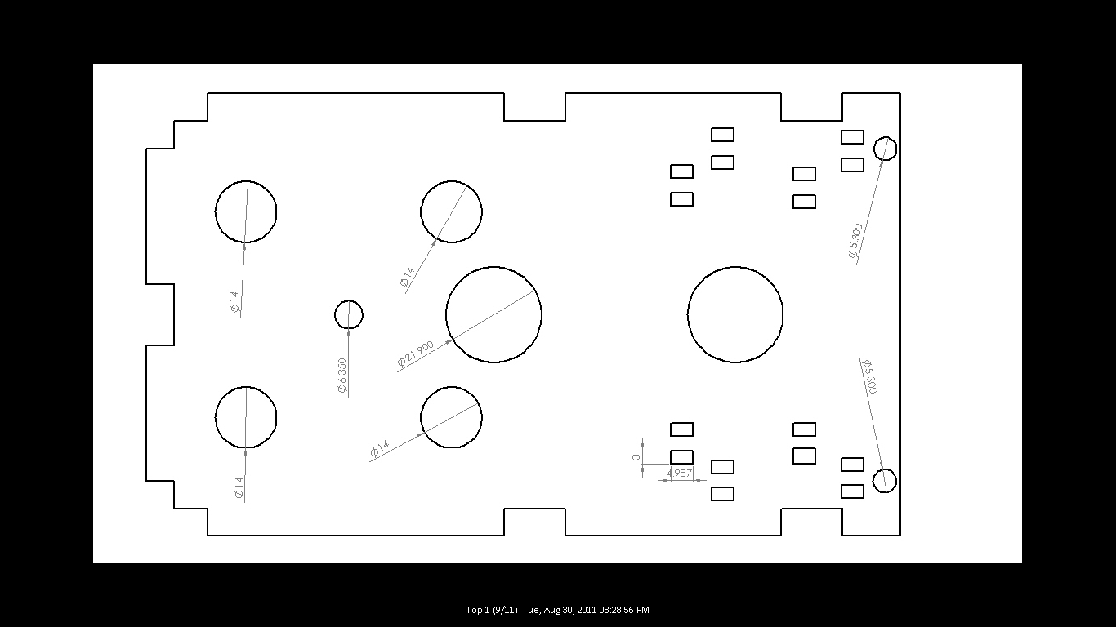

Fig. 6: *Top 1*

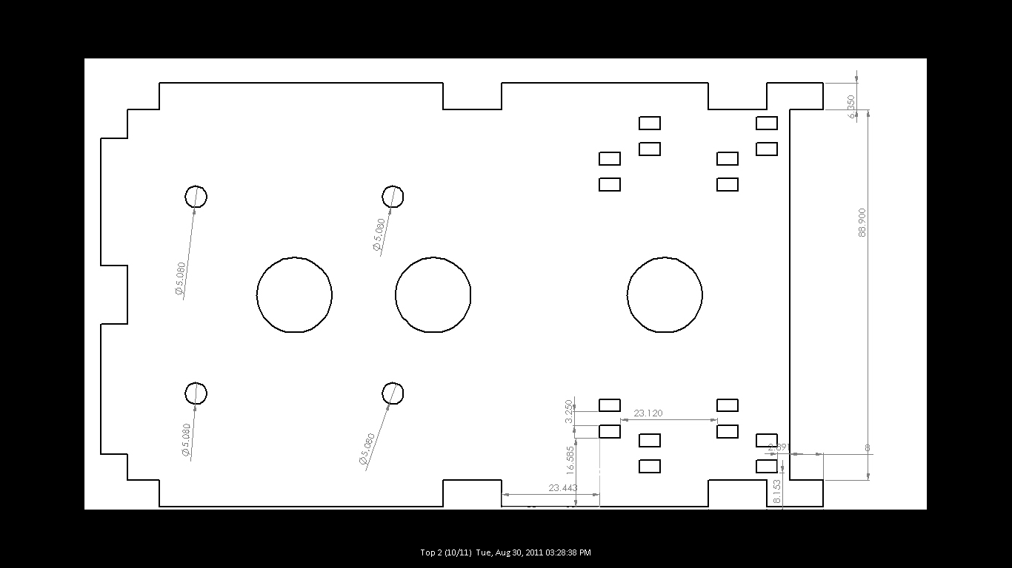

Fig. 7: *Top 2*

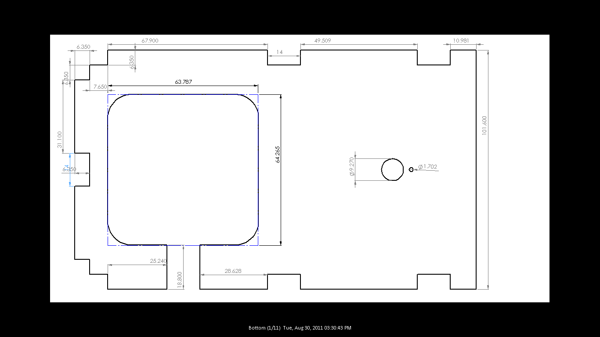

Fig. 8: *Bottom*

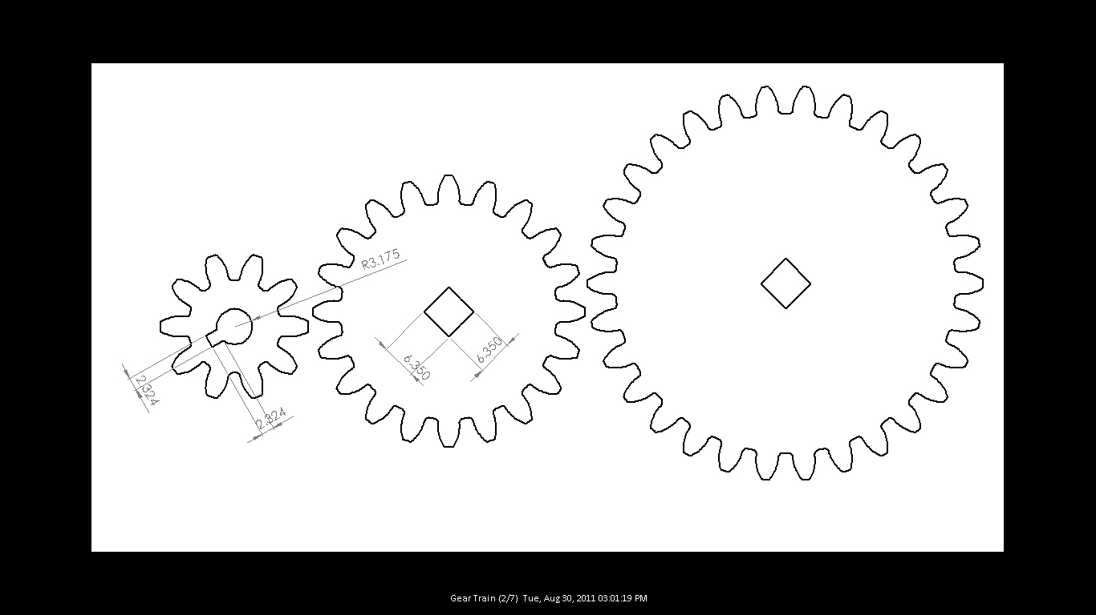

Fig. 9: *Gear Train (Left to Right: 10 Gear, 20 Gear, 30 Gear)*

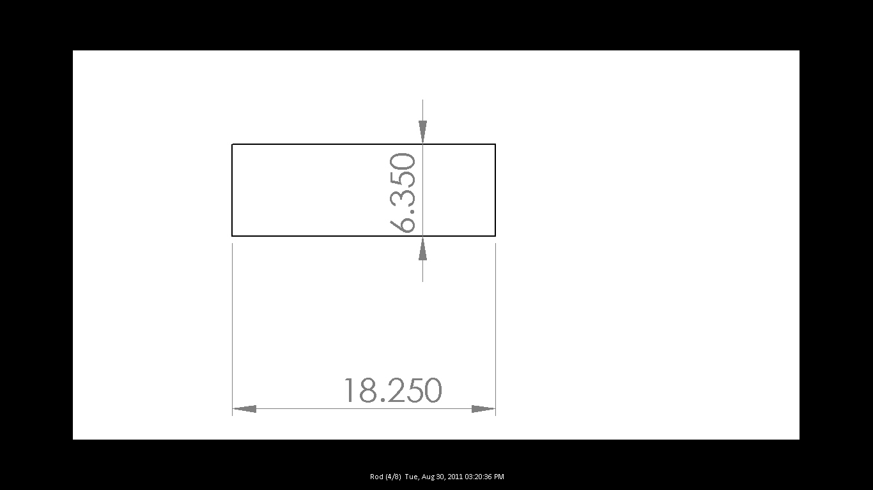

Fig. 10: *Rod*

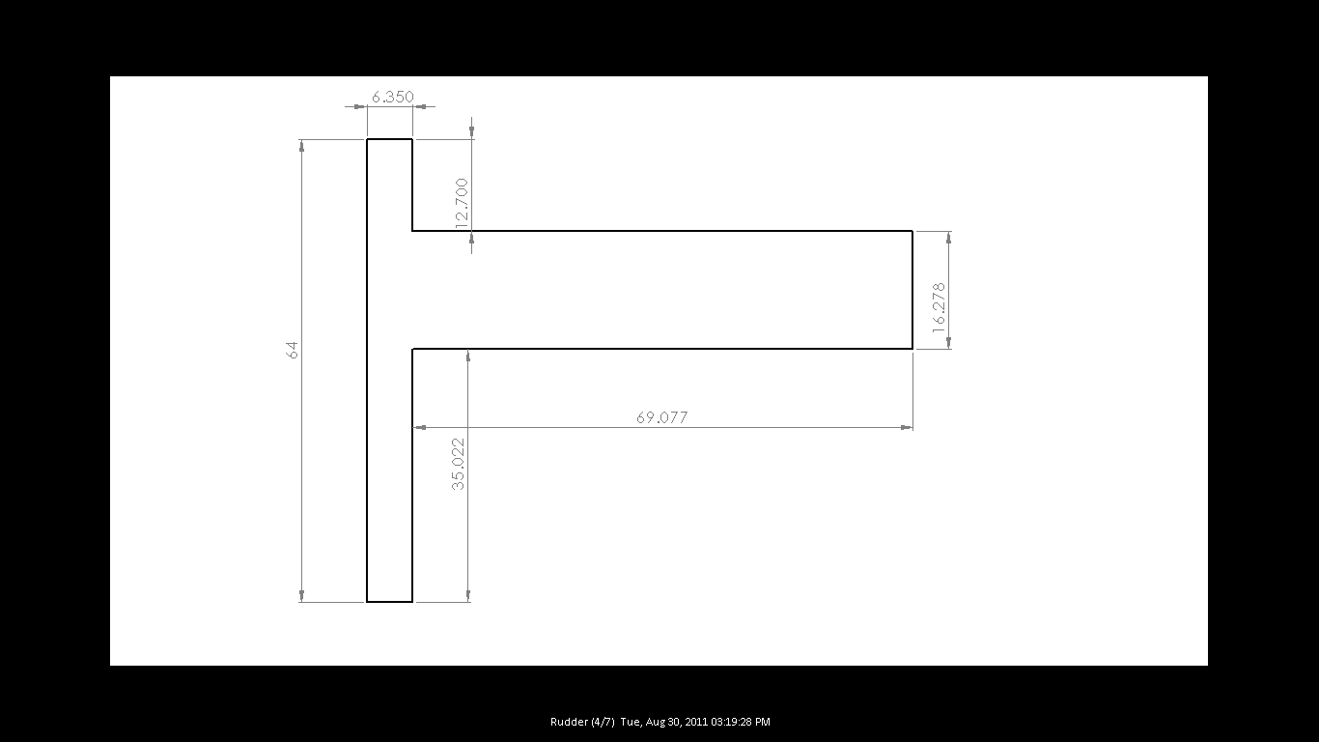

Fig. 11: *Rudder*

*c) Part 2: Laser Cutting*

Using:

- CorelDraw x4

- 30 Watt LaserPro Explorer II Laser Cutter/Etcher

- 1/4" Foamcore

- 1/4" MDF (Medium Density Fiberboard)

- 1/4" Acrylic

Having saved our Assembly as a .DXF file, what we do next is bring it over to another computer hooked up to our laser cutter and load it in CorelDraw x4. We do our laser cutting by printing it straight from there after putting our material in place and tweaking some printing properties.

Loading our Laser Cutter carefully consists of picking out a sheet of the material we want to use for the cut (making sure that it fits in the loading bay of the the laser cutter without hitting the carefully calibrated laser's head). After loading successfully we then fit as many 1/4" chips as it takes underneath the sheet we're cutting to keep the sheet it level. This is especially important with our laser cuter when cutting from a sheet that has already been partially cut. Such pieces are prone to bending when left on their own, doing this is the only way to ensure a clean straight cut. Putting the laser head right on top of the top left corner of the sheet we're about to cut we then autofocus the laser by pressing the auto focus button on our printer. This lets the laser know where the sheet is and allows it to adjust itself to the proper height to make a level cut.

Once we've got our sheet ready to cut, we can focus our attention on CorelDraw. The first thing we do is delete any crosses (that are not part of our design that appear over circles in our drawing). If we don't the laser cutter will mistakenly make extra cuts that waste power.

We then select all and change everything to red ink and thin line. This is important, for us to adjust the properties of the cut to fit the needs of the material and thickness we're using.

Pressing print, we then modify the printing properties according to the rules dictated by:

http://classes.soe.ucsc.edu/cmpe118/Winter11/LectureNotes/CMPE118_laser.pdf

We always change the settings to:

Under Pen Pen No. 2 (Red)

- Power: 100

- PPI: X

- Vector ON

- Air ON

- Raster Off

Under Advanced Settings

- Relative ON

- Vector Sorting ON

Power 100 cuts straight through, Vector cuts using lines, Air prevents the material being cut from catching fire by cooling it, Raser OFF ensures that the cut will not go back and forth along the same line, Relative makes the Corel Draw x4 top left corner start exactly where the laser beam starts, while Vector Sorting cuts parts inside out so that the piece doesn't fall out before it's complete (which sometimes gives uneven cuts).

As we are only dealing with 1/4" material, the speed we set the laser to depends on the type of material we are cutting:

for 1/4" Foamcore: 1.4

for 1/4" MDF (Medium-Density Fiber): 0.4

for 1/4" Acrylic: 0.5

Abiding by these speeds makes sure we get a clean cut that goes all the way through without burning the material.

For our design 8/11 pieces will be cut from MDF, and 3/11 from Acrylic. Initially when trying to put together a test model, we'd use Foamcore for everything which is cheaper and cuts faster.

MDF:

1. Front

2. Side w/ Port

3. Side

4. Bottom

5. Top 1

6. Top 2

7. Rudder

8. Rod

Acrylic:

1. Gear:

2. 20 Gear

3. 30 Gear

The reason we use MDF for the majority of our pieces is because is because it's proven to work for our laser cutter, and is strong enough for the job. The reason we use more expensive acrylic for our gears is that it cuts more smoothly and for pieces that we require to rub against each other a lot, the sliding effect that is produced by that smoothness guarantees longer service.

*d) Part 3: Assembly & Testing*

Using:

- Laser Cut Pieces

- Wood Glue

- Washers (x3)

- Hot Glue

- Motor

- Screws (x4)

- Screw Washers (x4)

- Vishay Potentiometer (x1)

- LEDs

- Zip Ties (x2 or x4)

- Hall Effect Sensors (x2)

- "Sockets" (x2)

- Wire (x10)

- Tape

- Breadboard

- Magnet (x1)

Once we have everything cut out, we can start gluing all the cut out pieces together just as we planned according to our SolidWorks assembly. Perfect for this job is wood glue, simply because just a little of it bonds MDF quite strongly. With our box complete, We can then put in our washers, LEDs, Zip Ties, and Hall Effect Sensors. After that, all we got to do is get our electronics wired together before finishing everything off by taping our magnet in just the right place.

For someone unfamiliar to where things fits these next few pictures might help. The final construction should look something like this:

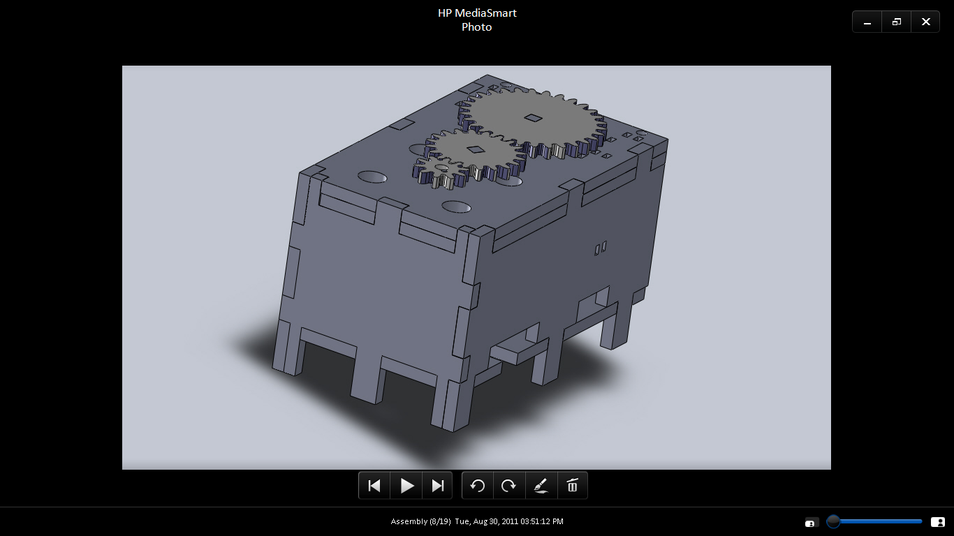

Fig. 12: *Front Left* *Finished Rudder Box Assembly in Solid Works*

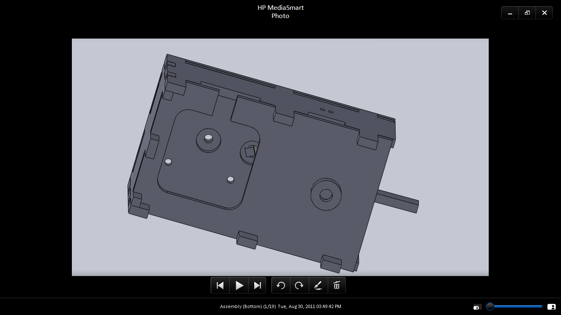

Fig. 12: *Bottom View* *Finished Rudder Box Assembly in Solid Works*

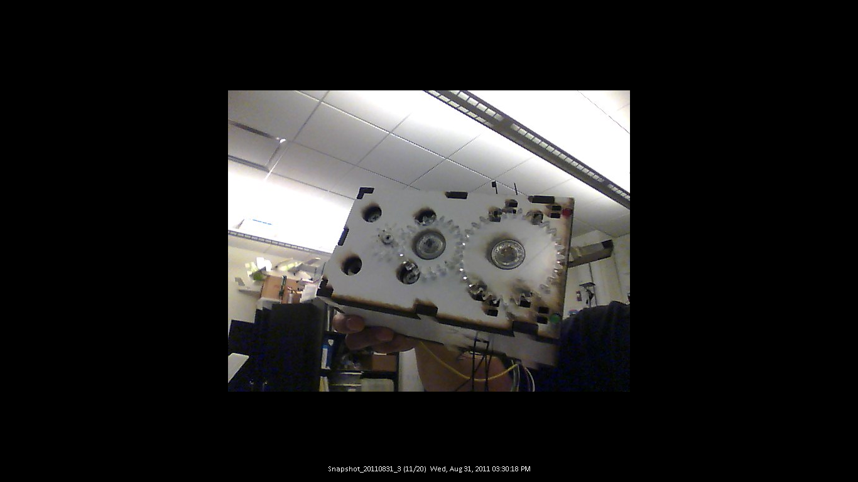

Fig. 13: *Top View* *Finished Rudder Box*

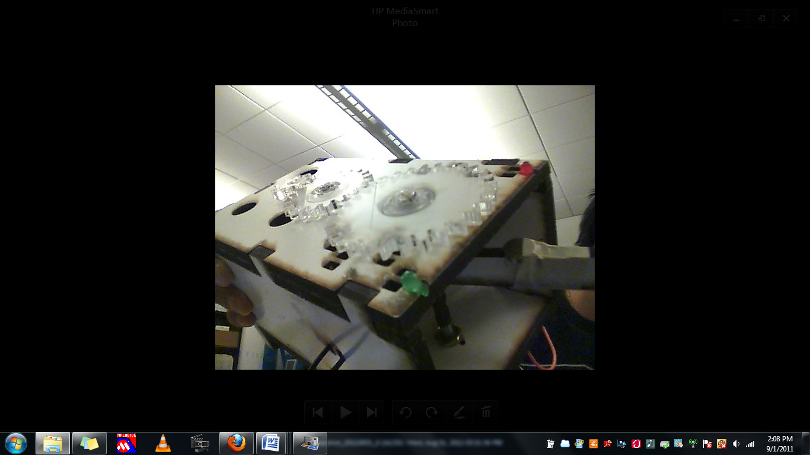

Fig. 14: *Slanted* *Top View* *Finished Rudder Box*

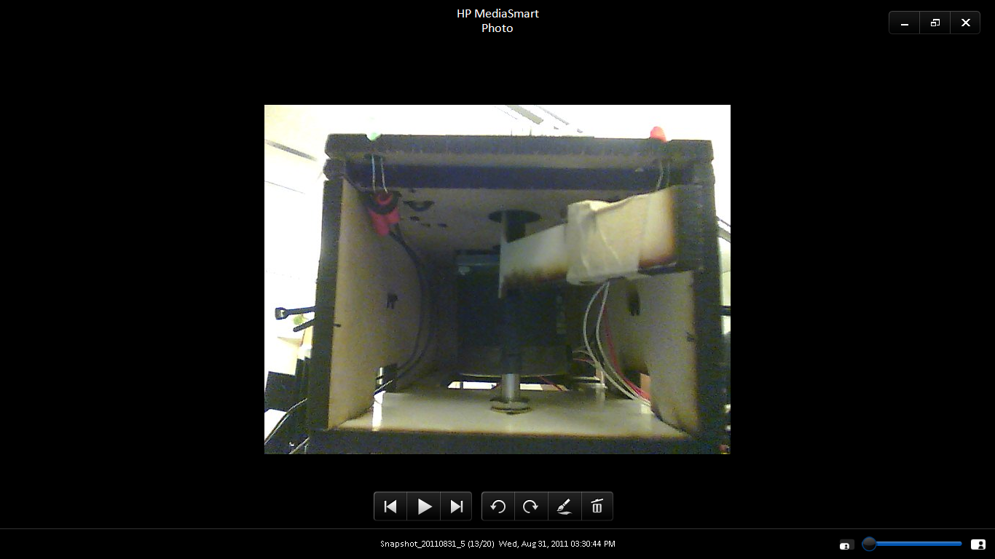

Fig. 15: *Back View* *Finished Rudder Box*

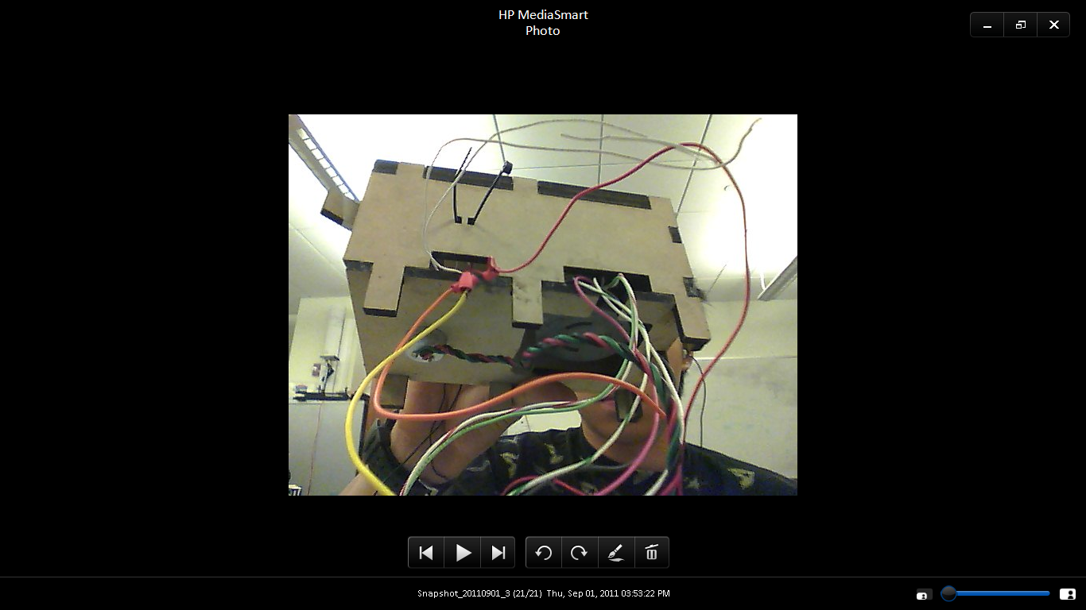

Fig. 16: *Side With Port & Bottom Opening Connection*

"Top 1" should be on top of "Top 2", and these should be flanked by the "Sides". Top 1 has two circle holes at one long end whereas Top 2 doesn't. These holes are where the LEDs mount (pictured as Red and Green in Fig. 13-16). Which side is the port side is determined by which side of the Bottom has the opening to the big square cut in it. They should both match up as pictured in Fig. 16.

All the edges of the box where one side touches another should be glued using wood glue. The motor should be shoved through the hole in the Bottom and secured by screwing it on top through both Tops. Washers should be put through the two holes where they fit on Top 1. The one rod should go through the middle one, while the rudder top should go through the back one (the back being the open end of the box). The top of the rod will be the longer part. Gears should then be placed on each of the three mounts (the 10 Tooth Gear at the front with the motor, the 20 Tooth Gear in the middle with the rod, and the 30 Tooth Gear at the back with the rudder).

Hot gluing the tops of these should be done later when the rudder has been set to the correct height. Do this as a last step after testing.

Once our box is assembled, and everything but the electronics have been set in place, we need to put those parts in with the magnet and test that it actually works. With our LEDs already in, we need to identify which one is the anode and the cathode, or + or - so we can wire our circuit according to this diagram that also includes our other electronic part (the Hall Effect Sensor):

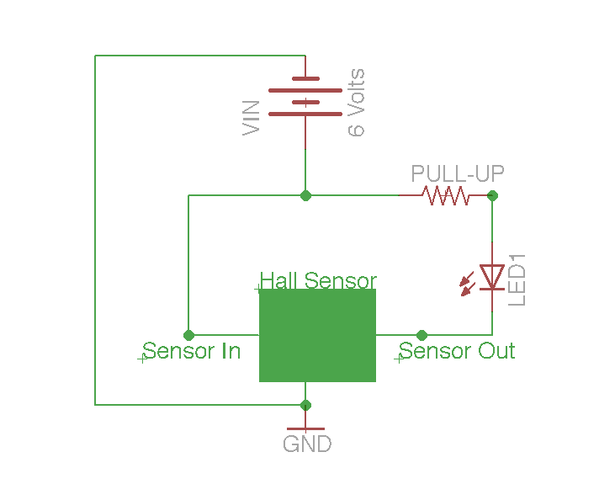

*Fig. 3: Hall Effect Sensor Circuit Diagram*

The anode is the longer leg, while the cathode is the shorter leg. Bending these legs towards the inside of the box, we can solder pieces of wire to these and put heat shrink over them and pull them through a port and wire them to a bread board.

We will be putting the heads our Hall Effect Sensors right above the backmost inside zip tie holds, with their metal rods pointing towards the inside of the box. The ziptie holes are the all the small cuts that permeate the back of Tops 1 and 2 and feature somewhat on the Sides. To secure our Hall Effect Sensors, what we do is put them each into a socket and tape it to the bottom of Top 2. Using Zip ties is optional, but if we want to use them we have to put it through from under and cut off excess zip tie, as tie it to the top Top 1 like you might regularly do with a zip tie would impede our Gears.

Using Fig. 3 above as our guide we then wire everything together and connect the circuit into a breadboard.

What should happen is that one LED should light up every time it's corresponding Hall Effect Sensor detects the north face of a magnet. We want this to occur when the rudder upon which the magnet is mounted hits either extrema of 45 degrees right or left. Once we know our circuit is working, we can put a magnet at the back of the rudder and see about where it successfully does this (which turns out to be about the center). We can then tape it down, and if the LED above a corresponding Hall Effect lights up, when the Rudder has reached it's farthest extent to said side, everything will have been complete.

*e) Part 4: Redesign*

At this stage, we go back and make the adjustments in SolidWorks we've found that we needd to make using the same tools we used for parts 1-3.

When we did this project we had roughly 6 major reiterations according to the notebook we kept as we worked.

*Reiterations:*

Iteration 1: Open Back Box

What we first produced was four walled rectangular box with an open back.

Iteration 2: +Washer Holes, +Gear Train

We then cut 3 holes to allow washers to fit through the top of the box, and we also cut out a working three gear gear train.

Iteration 3: + Motor Holes, +Double Top, + MDF Gears to Acrylic Gears

After that we changed the front of the 3 washer holes and made it smaller for the motor head. We also added four holes for the screws to secure the motor. To help our gears stop slipping we added a second top as well that had holes slightly smaller than he top. We then changed our gears from MDF to Acrylic as that would help our gears move more smoothly.

Iteration 4: + Rudder, + Vishay Potentiometer Hole

We then added a rudder, and a hole for the Vishay Potentiometer as well as a model in SolidWorks.

Iteration 5: +Legs, + Side Ports, + Motor Easy Insertion Hole

To make room for the Potentiometer at the bottom, we raised the box so it would have stilts to stand on, we also cut side ports for wiring, and made a big hole in the bottom for easy motor insertion.

Iteration 6: + LED, +Zip Tie Holes,

The last thing we did was make room for our LEDs on Top by modifying our double top, with fitting configurations added, and a bunch of Zip Tie Holes for us to help secure our electronics.

Iteration 7 (to be done): + Rudder Groove Fitting Magnet, + Fitting Hall Effect Sensors, - Ziptie Holes

If we were to do one more reiteration we would cut a grove in the rudder for where the magnet is supposed to be, and a groove for the Hall Effects in Top 2 for where they are supposed to fit. That way there would be no need for making measurements during assembly. To remove unnecessary complexity from our rudder box we may opt to remove our zip tie cuts.

[3] Our Thoughts

*a) Overview:*

Designing and building what eventually became our final version of our rudder box took longer than it should have. It took about a month of many reiterations of CAD, laser cutting, and assembly before we were able to get what we now have, when really it should have taken a week to piece together. The reason it took so long was that the main person we had working on it came into the project knowing absolutely nothing about the techniques and processes involved and as a way of teaching him a great deal about our lab and the techniques utilized by our lab we had him try to improve his design with a new iteration each time he thought the job was complete.

By week one he had a working box in SolidWorks, that while lacking many of the intricacies of our later versions, could still with a few more cuts do a fine job as rudder box. It just needed holes for a rudder, screws for the motor, and room forthe potentiometer at the bottom of the box. The motor could be put in first before the bottom, screwed in, and it's wires could just pop out the back. Even though it wasn't the final product we wanted, we decided to get it cut out by the laser cutter anyway so the student could get more time in using the laser cutter, and could have a physical translation of the work he had done using CAD. We found the box to be acceptable and moved onto trying to get a 3 gear gear train as our next step.

Trying to make gears from scratch led us to try find a gear template. It took us about a week before we finally found what we wanted and understood how to use it right by adjusting the ratio of # of teeth to pitch diameter. Getting up to speed on understanding all the math behind building a properly constructed gear made any work done from scratch a non cost-effective solution.

Once we figured out how to do this, getting the three types of gears we wanted was easy, all we had to do was adjust a couple of numbers.

By week three we reassessed our design to be more ergonomic towards our gear train. We added a second top, and resized our washer holes so that the washers would fit under the 1st top so that between the rod and the gears there would be very low friction. The washers were friction fit to our top layer, and stopped from dropping with a little edge from the bottom one (Top 2). We then changed the material from which we cut our gears. We went from MDF to Acrylic because of its stronger and moves more smoothly. It's also from this point we adopted the technique of putting posts underneath the sheets we're cutting to ensure and clean/level cut. We also shifted between a bunch of different cuts for the screwdrivers, and changed the hole for our smallest 10 teeth gear to fit the motor. Once we were happy with that we started adding a rudder piece and potentiometer to the mix to see how much that would change our design.

The addition of these two elements necessitated for a lot more change than we'd initially anticipated. Needing to have a raised platform for the potentiometer to sit comfortably underneath the box, we had to make changes to our box that accidentally or unintentionally changed other things we didn't mean to change--resulting in a need to redefine and re-measure a number of the different relations that made up our box. By the end of the 4th week we had a better box that fit everything and even had a hole underneath the motor for easy insertion and removal after assembly

At this time the box was basically done, it could completely and comfortably route rudder angles, etc. etc. But instead of stopping there we decided at this point to add a Hall Effect sensing system with LEDs that would signal when our rudder hit either extrema of 45 degrees right or left. Adding this to the plan was consistent with our goals. It would have a practical application of lighting up whenever the rudder hit a full right or left turn, and second it would provide our "initiate" an introduction to working with electronic circuits.

At this point, came some playing around with and testing of hall effect sensors and learning how to read circuit diagrams and wire them in real life. Once we got comfortable understanding what we were working with we started moving in on getting it installed on our rudder box.

At this stage, entering our 5th week, we decided to make a bunch of little adjustments to fit the Hall Effect sensors and LEDs, aligning our rudder angle perfectly at 45 degrees, setting up ports for our wires to be able to get get out without causing any interference to our rudder system, and to cut holes through both tops to make room for Zipties to secure our wires away from getting caught in the rudder. We made all the changes and found out that there were some complications surrounding the Zipties.

First of all it was very troublesome to perfectly aligning cuts along two different top layers, in CAD, it required measuring, drawing and re-measuring. Second, the Zipties couldn't be used without clipping off the tie and just using it to friction fit simply because the heads coming off the top ran into the 30 gear. And lastly, only two out of eight planned cuts were of any use, and even then only minimally to secure the head's of the Hall Effect sensors. Tape ended up working much better than zipties without ties that kept falling out, so that's exactly what we ended up using.

With that and a little more testing, a little more confidence in our electronics, our rudder box was complete.

Overall we feel the job was a success, and though it could have been done faster, made up for itself by being both a useful product and a teaching aid to our new lab member.

*b) Possible Upgrades:*

If we were to do this whole project again it would probably have been completed in a week, spending different days to do different things:

Day 1: Drawing & Measurements

- Box

-- has to fit motor, washers, correctly spaced gear holes, holes for LEDS, wiring, potentiometer

- Gears

-- 3 correct ratios/distances

- Rudder

Day 2: CAD

- Box (6 pieces)

- Gears and Rod (4 Pieces)

- Rudder (1)

Day 3: Laser Cutting/Assembly

- Box

- Motor

- Potentiometer

- Rudder

- Gears

Day 4: Fixes/Assembly

Day 5: Wiring

- LEDs

- Hall Effect Sensors

- Wiring

It might take more time than this but this + or - some checking should be everything you need to construct a rudder box.

*Upgrades*:

There would be 3 places we'd like to make upgrades:

* Add notch for Hall Effects in Socket in Top 2

- This reduces the need to make measurements on where to put the Hall Effects

*Add notch in for magnet on top of the rudder to fit it's correct location

- This reduces the need to make measurements on where to put the Magnet

* Remove Zip Tie Cuts

- This gets rid of unnecessary features.